# Insights from InterBank Call Rate Data:

Fig1: Time series analysis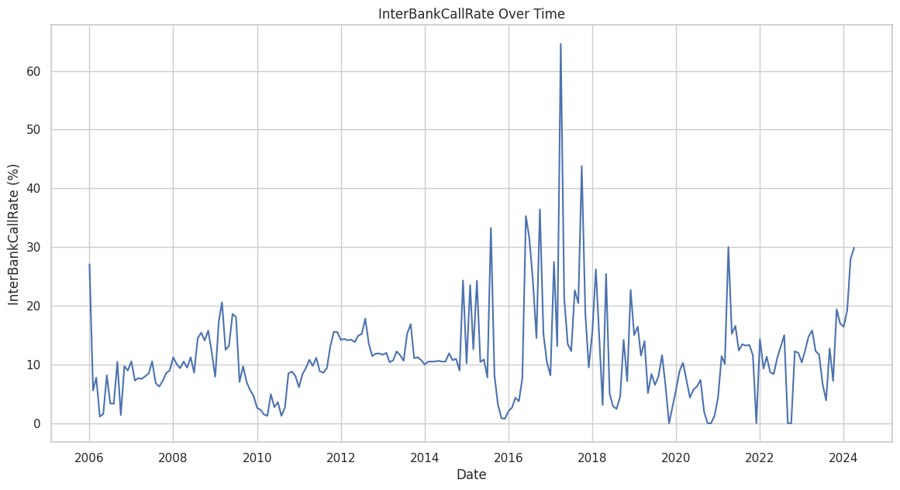

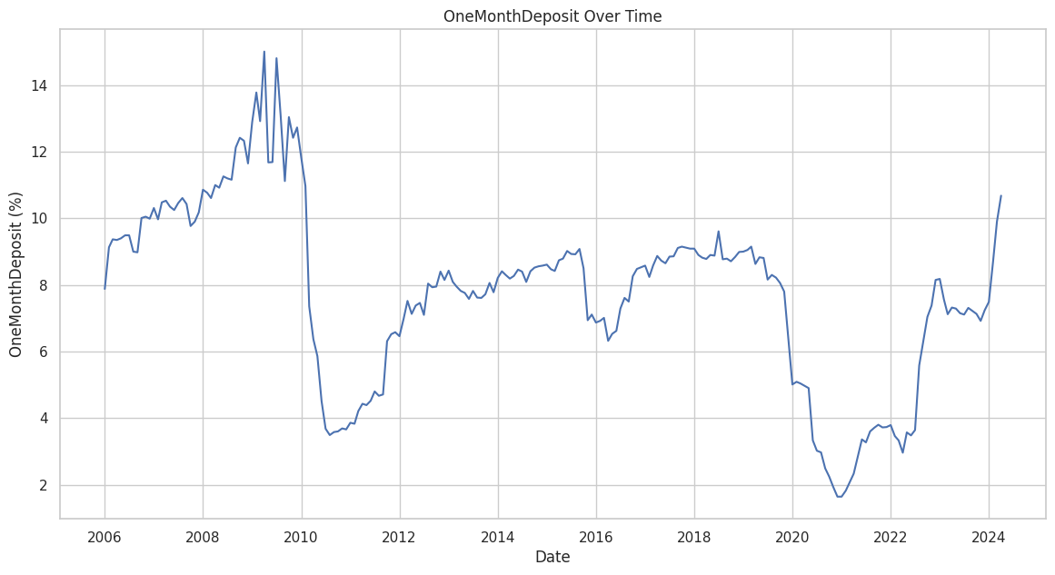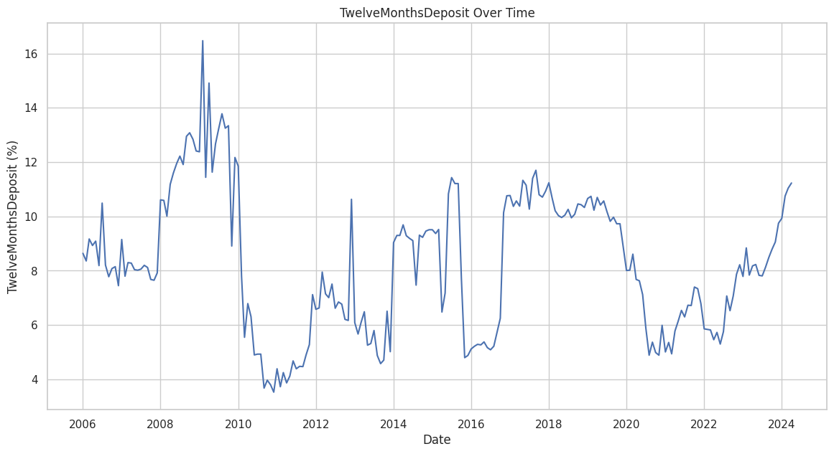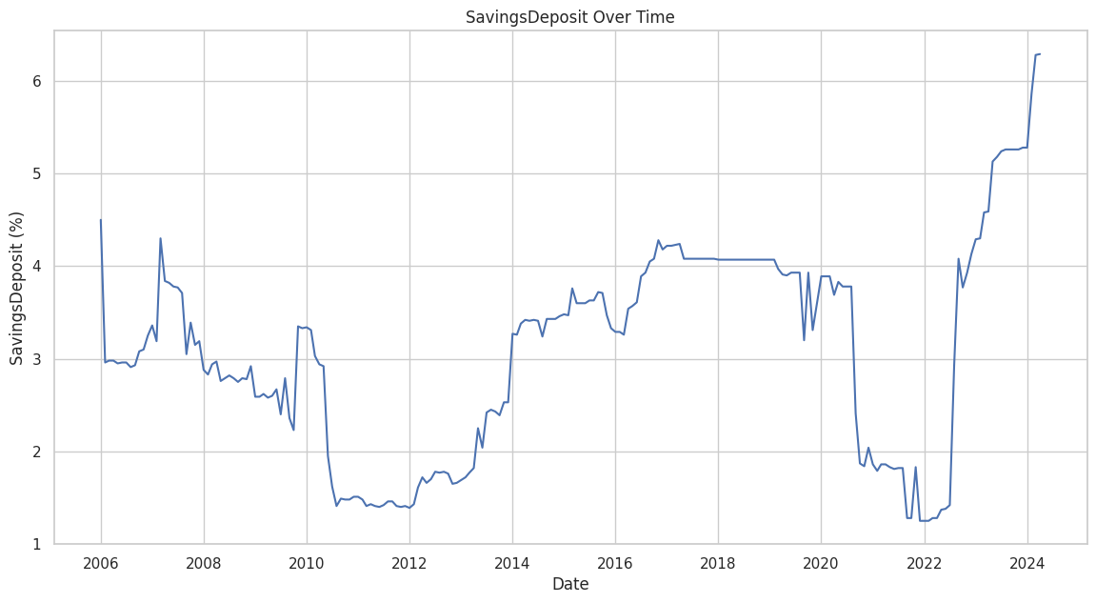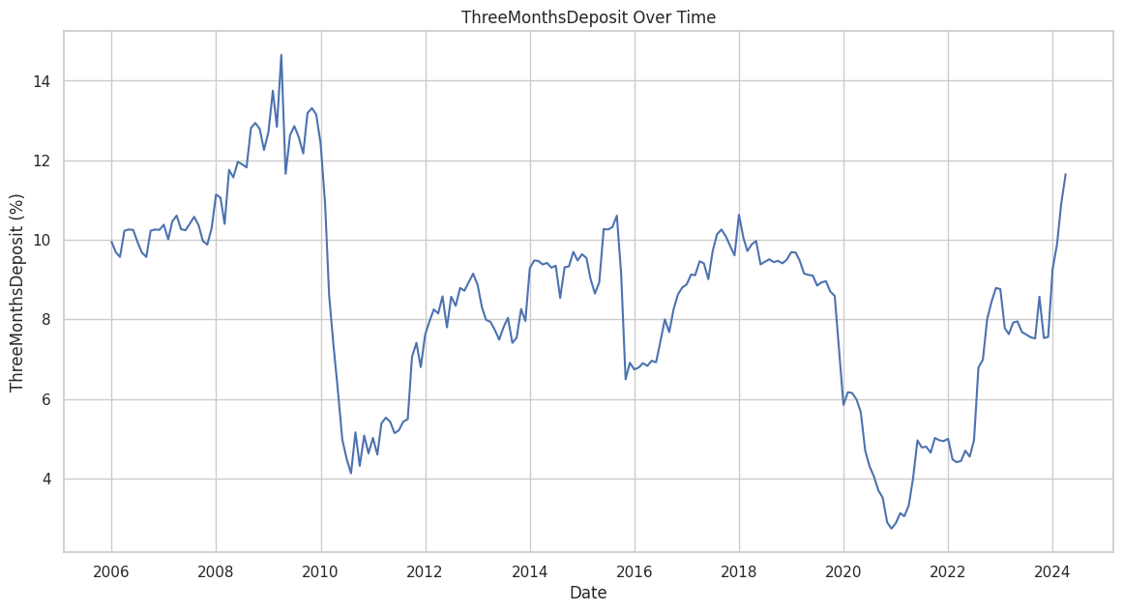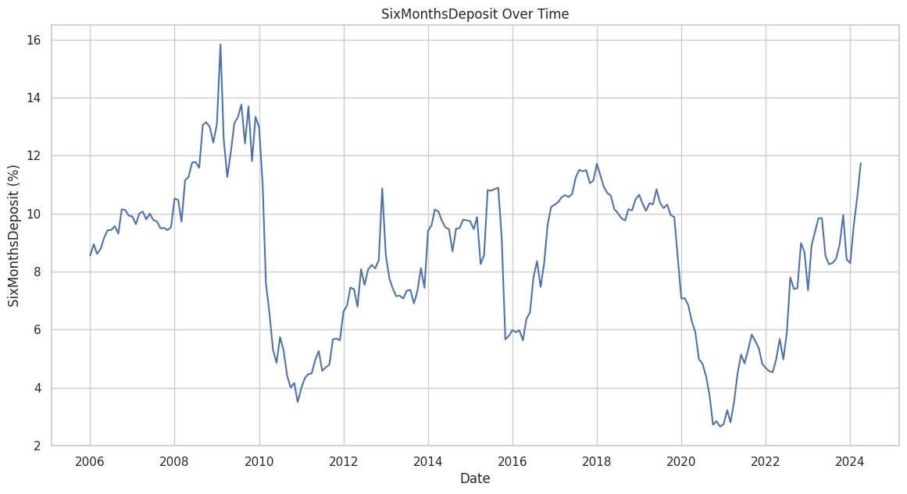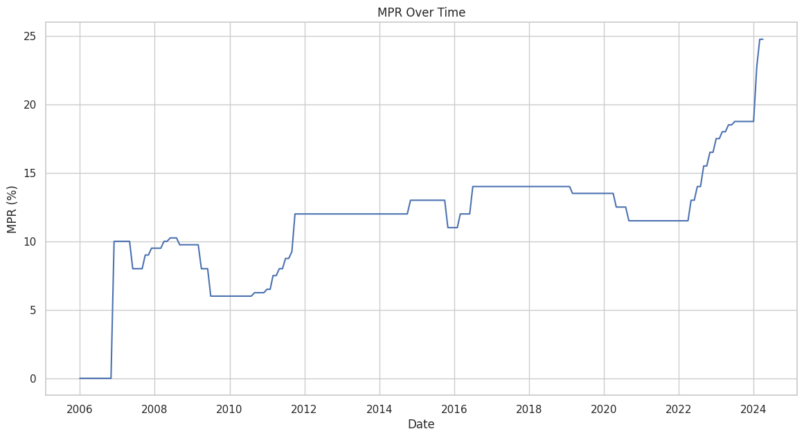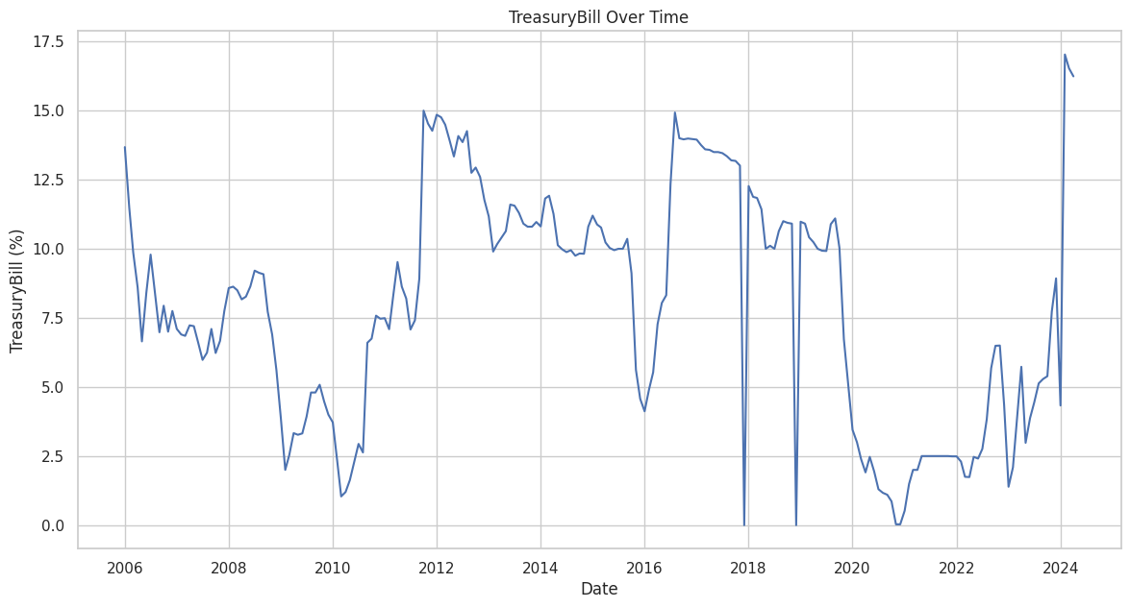

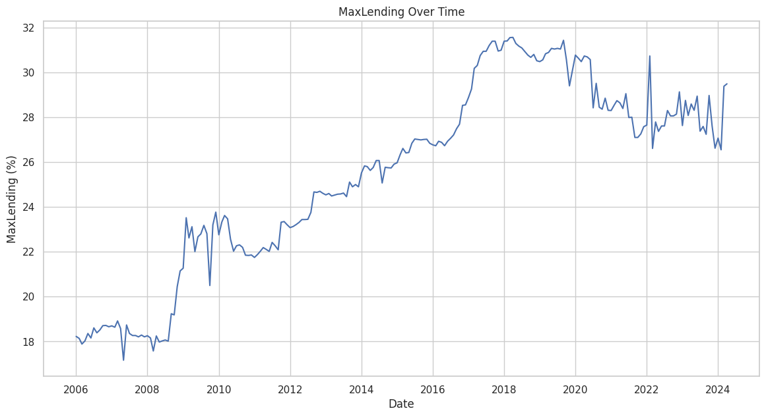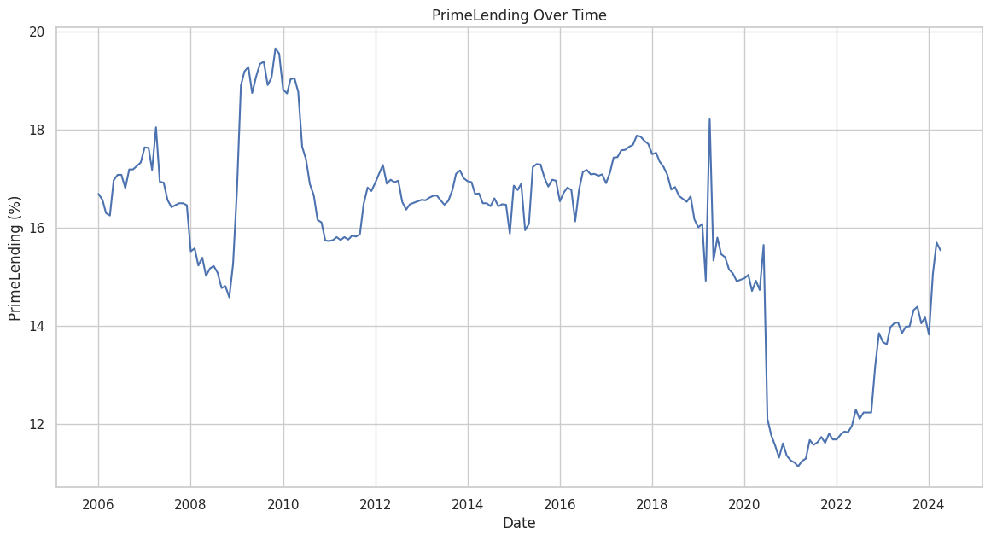

* The graph titled “InterBankCallRate Over Time” illustrates fluctuations in the Interbank call rate from 2006 to beyond 2024, with notable spikes and drops, reflecting the dynamic nature of interest rates in the banking sector.
* The line graph titled “MPR Over Time” shows that the MPR Rate has periods of stability followed by sharp increases, with a significant spike after 2022, suggesting a major event or change impacted the rate.
* The “Treasury Bill Over Time” graph depicts fluctuations in the Treasury bill rate from 2006 to beyond 2024, with peaks and troughs indicating varying investment attractiveness over time.
* The graph “Savings Deposit Over Time” shows the savings deposit rate fluctuating between 2006 and beyond 2024, with noticeable peaks and dips, reflecting changes in savings behaviour or economic conditions.
* The “ThreeMonthsDeposit Over Time” graph indicates variability in the three-month deposit rate from 2006 to around 2024, with several peaks and troughs highlighting changes in short-term interest rates.
* The “SixMonthsDeposit Over Time” graph shows the six-month deposit rate fluctuating between 2006 and 2024, with peaks and troughs indicating significant changes in the rate, particularly around 2008 and 2020.
* The “TwelveMonthsDeposit Over Time” graph shows the twelve-month deposit rate fluctuating between 2006 and beyond 2024, with peaks and troughs indicating significant changes in the rate over time.
* The “MaxLending Over Time” graph shows a generally increasing trend in the MaxLending rate from 2006 to beyond 2024, with fluctuations and a notable rise after 2016, indicating changes in maximum lending rates over time.

Fig2: Box plot providing a summary of the distribution of various deposit rates

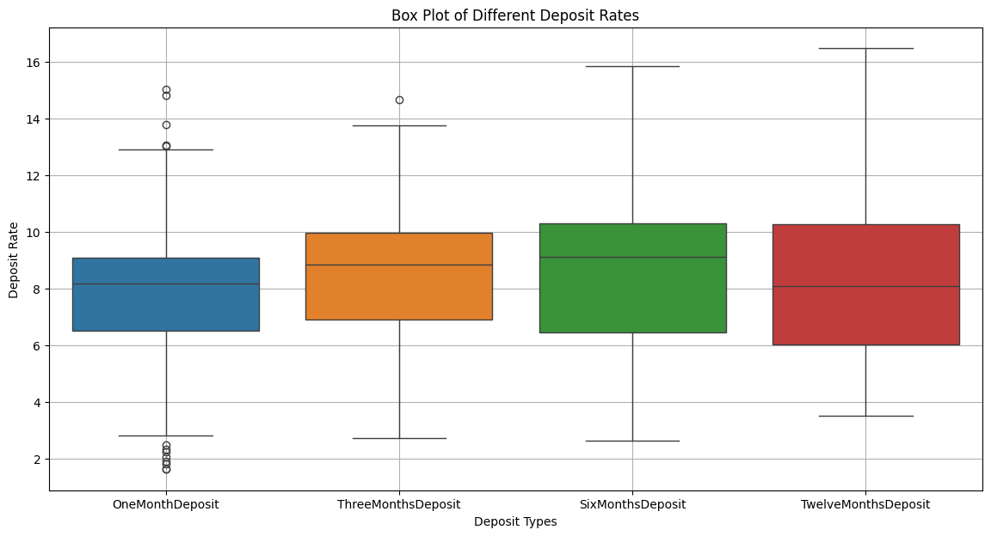

* The OneMonthDeposit has the narrowest interquartile range (IQR), indicating less variability in deposit rates compared to other types.
* The ThreeMonthsDeposit and SixMonthsDeposit have similar median values, but the SixMonthsDeposit shows slightly higher variability.
* The TwelveMonthsDeposit has the highest median and exhibits some exceptionally high rates.
* Longer-term deposits (e.g., TwelveMonthsDeposit) generally offer higher rates but come with increased variability.
* Shorter-term deposits (e.g., OneMonthDeposit) have lower variability but offer lower rates.
* Investors and institutions should consider their risk tolerance and investment horizon when choosing deposit types.
* Balancing risk and potential returns is essential for optimizing interest earnings.

Fig3: The correlation heatmap describing the correlation coefficients between all pairs of variables in the dataset

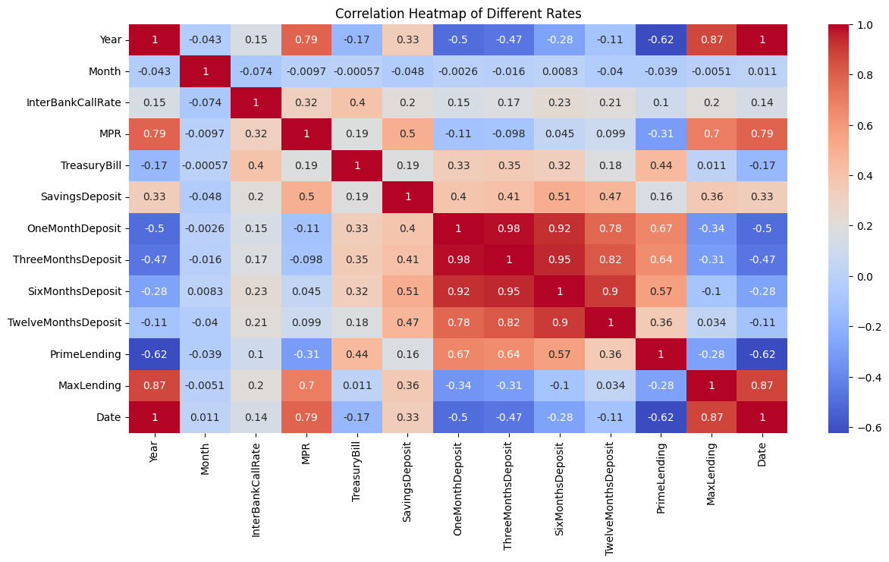

**High Positive Correlations:**

1. **OneMonthDeposit and ThreeMonthsDeposit** (0.98): These deposit rates are very highly correlated, indicating that they tend to move together.
2. **ThreeMonthsDeposit and SixMonthsDeposit** (0.95): Similarly, these rates also show a strong positive correlation.
3. **SixMonthsDeposit and TwelveMonthsDeposit** (0.90): These rates are highly correlated as well, suggesting consistency in the movement of deposit rates across different time periods.
4. **MaxLending and Year** (0.87): This strong correlation suggests that maximum lending rates have a consistent upward trend over the years.
5. **MPR and Year** (0.79): The Monetary Policy Rate also shows a positive trend over the years, indicating potential policy changes over time.

**High Negative Correlations:**

1. **PrimeLending and Year** (-0.62): Prime lending rates have a significant negative correlation with the year, indicating a downward trend over the observed period.
2. **PrimeLending and MaxLending** (-0.62): This indicates an inverse relationship between prime lending rates and maximum lending rates.

**Moderate Positive Correlations:**

1. SavingsDeposit and TreasuryBill (0.50): There is a moderate positive correlation, suggesting that as treasury bill rates increase, savings deposit rates tend to increase as well.
2. TreasuryBill and PrimeLending (0.44): This indicates that higher treasury bill rates are moderately associated with higher prime lending rates.
3. TreasuryBill and SixMonthsDeposit (0.32): A moderate correlation between treasury bills and six-month deposits indicates some degree of association.

**Moderate Negative Correlations:**

1. PrimeLending and InterBankCallRate (-0.31): This suggests that as interbank call rates increase, prime lending rates tend to decrease.
2. PrimeLending and OneMonthDeposit (-0.34): A negative correlation, indicating that higher prime lending rates are associated with lower one-month deposit rates.

**Weak or No Correlations:**

1. Month with Most Variables: The month shows very weak or no correlation with most of the other variables, indicating that monthly changes do not have a significant impact on these rates.
2. SavingsDeposit with InterBankCallRate (0.20): A weak correlation, suggesting a limited relationship between these two rates.

**Key Takeaways:**

1. **Trends Over Time**: There are clear trends over the years, with 'MaxLending' and 'MPR' increasing over time, while 'PrimeLending' decreases.
2. **Interrelationships**: Deposit rates across different terms (one month, three months, six months, twelve months) are highly correlated, indicating they move together.
3. **Policy Impact:** The correlation between 'MPR' (Monetary Policy Rate) and other rates like 'InterBankCallRate' shows how central bank policies might influence market rates.
4. **Divergence in Lending Rates:** The inverse relationship between 'PrimeLending' and 'MaxLending' rates might suggest different factors influencing these rates.

Fig4: the average rates for each year, providing a year-over-year comparison

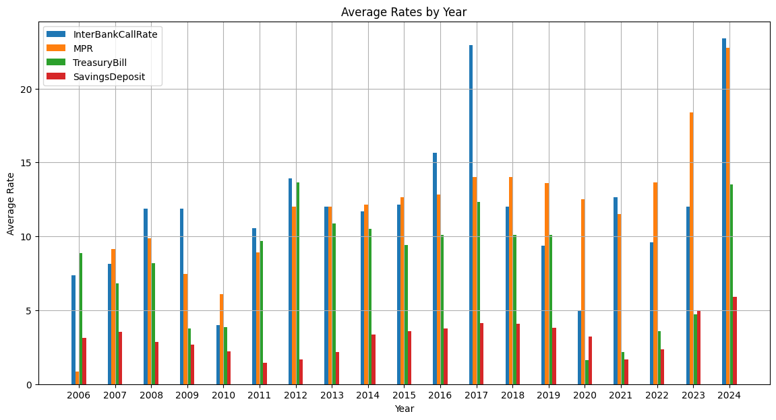

1. **InterBank Call Rate:** There is a noticeable increase in the InterBank Call Rate over time, peaking in 2024. This indicates increasing borrowing costs between banks.
2. **MPR:** The MPR also shows an upward trend, particularly noticeable in 2024, suggesting tightening monetary policy.
3. **Treasury Bill Rates**: Treasury Bill rates have significant fluctuations, with a major spike in 2023. This could be due to government actions to control liquidity or other economic measures.
4. **Savings Deposit Rates:** The Savings Deposit rates have remained relatively stable with a slight increase in recent years, reflecting modest changes in savings incentives for consumers.
5. **2006 to 2010:** The rates were relatively low and stable during these years, indicating a period of economic stability or lower inflationary pressures.
6. **2011 to 2016:** There is a marked increase in rates during these years, suggesting possible economic instability, inflationary pressures, or tighter monetary policies.
7. **2017 to 2020:** Rates are generally stable with some variations. The economic conditions may have been relatively balanced during these years.
8. **2021 to 2024:** A sharp increase in rates, especially noticeable in 2023 and 2024, points to significant economic events or policy changes driving these rates up.

Fig5: Pair plot analysis

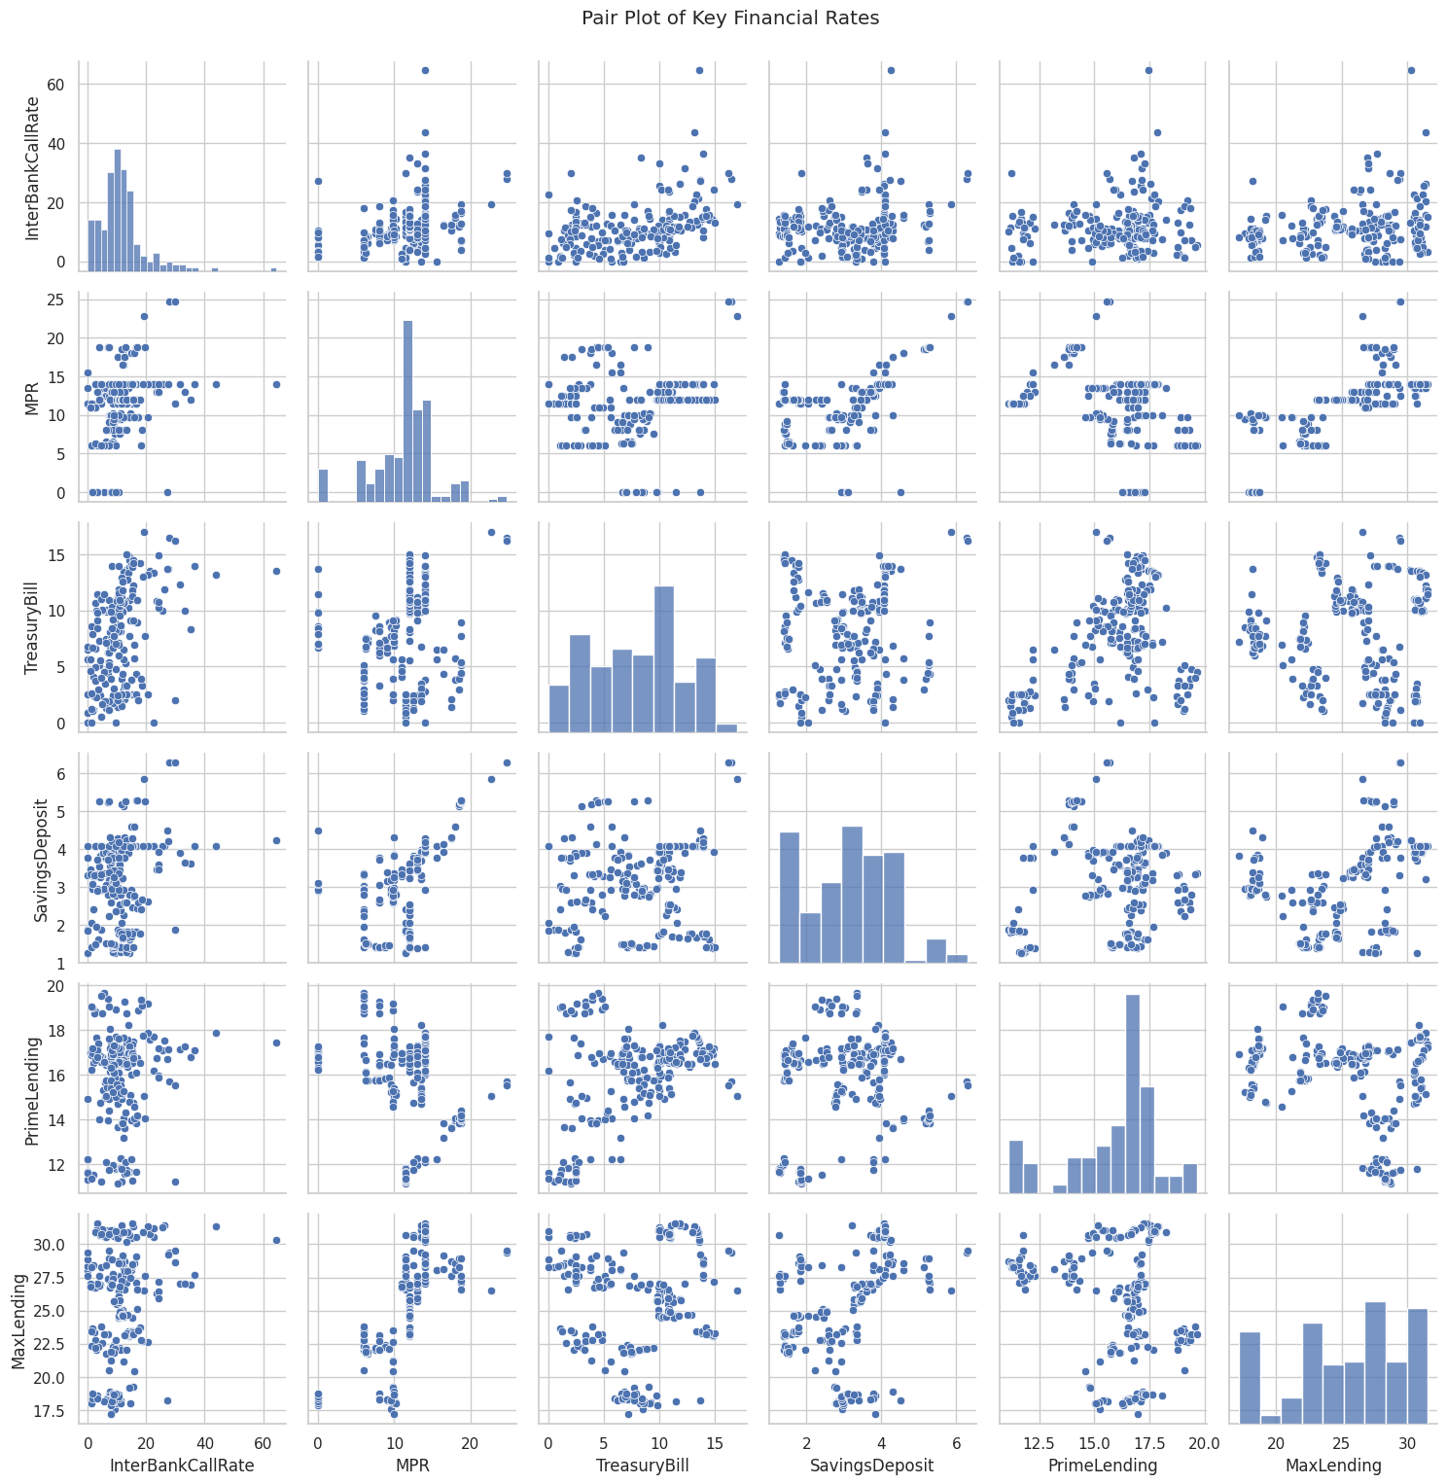

The distribution of InterBankCallRate appears to be skewed, with most values concentrated around 10%.

There seems to be a positive correlation between InterBankCallRate and TreasuryBill.

The NPR distribution is not visible in the image, but it likely varies across the years.

There might be some relationship between NPR and SavingsDeposit.

The TreasuryBill rate shows a wide range of values, with some extreme fluctuations.

There is a positive correlation between TreasuryBill and InterBankCallRate.

SavingsDeposit rates are relatively stable over time, with values around 15%.

There might be a negative correlation between SavingsDeposit and InterBankCallRate.